​Phase 1 Project Report: Intelligent Loan Eligibility Analyzer
Project Name: Intelligent Loan Eligibility Analyzer
Phase: Phase 1 — Rule-Based Risk Engine & End-to-End System
Tech Stack: FastAPI (Python), PostgreSQL, React.js (Vite), JWT Security
Status: Verification Completed & Production Ready

1. System Overview
The Intelligent Loan Eligibility Analyzer is a multi-tier banking application designed for automated credit decisioning, risk evaluation, and loan workflow management.
Phase 1 establishes the rule-based risk evaluation architecture, enforcing Indian banking underwriting guidelines including Fixed Obligation to Income Ratio (FOIR) limits, credit score risk tiering, income checks, and default history verification.
Core Architecture
- Frontend Layer: React 18 SPA (Vite) with Ferrari Dark Design system, asynchronous state handling, and client-side validation.
- Backend API Layer: FastAPI (Python 3.10+) implementing RESTful endpoints, CORS policy enforcement, Pydantic data contracts, and JWT Bearer security.
- Data Layer: PostgreSQL 15 containerized database managed via SQLAlchemy 2.0 ORM with connection pooling.
- Risk Engine: Centralized rule evaluation engine calculating FOIR caps (50% Salaried / 60% Self-Employed), risk categorization (​LOW​, ​MEDIUM​, ​HIGH​), approval probabilities, and maximum recommended credit limits.

2. Rule-Based Evaluation Engine Specifications
The Phase 1 risk engine strictly implements the financial underwriting criteria defined in the project specification:
Risk Matrix & Criteria
Risk Tier | Credit Score | FOIR Constraint | Default History | Approval Probability | Action Recommendation
LOW RISK | > 750 | < FOIR Cap | 0 missed payments | 92.00% | Pre-approved up to recommended limit
MEDIUM RISK | 650 – 750 | ≤ FOIR Cap | Any | 65.00% | Standard processing / Manual review
HIGH RISK | < 650 | > FOIR Cap | > 2 missed payments | 30.00% | Reject application / High default risk
Key Mathematical Formulas



3. End-to-End User Flow Verification
The system was verified end-to-end using automated browser testing and manual session validation. Below are the verified screens and metrics.
3.1 Authentication & Security Layer
- User authentication via JSON Web Tokens (JWT) with HS256 signature validation.
- Standardized error codes (401/403) and automatic frontend session redirection on token expiration.
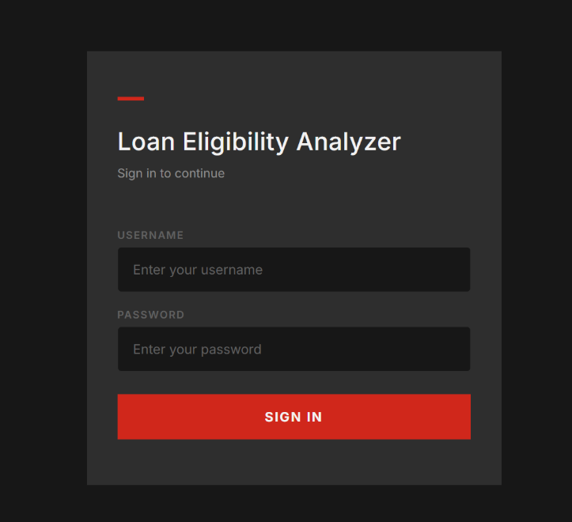

3.2 Loan Officer Dashboard
- Real-time application statistics breakdown (Total, Approved, Rejected, Pending).
- Multi-tenant application isolation based on logged-in user credentials (​submitted_by_user_id​).
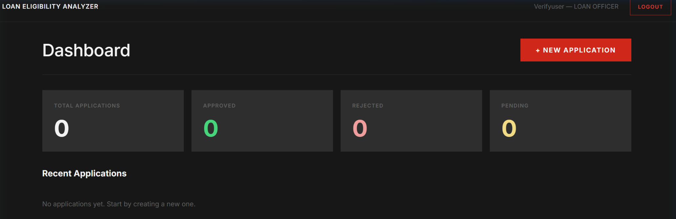

3.3 New Loan Application Intake
- Comprehensive intake form collecting Personal, Employment, Financial, Credit, and Loan Request details.
- Real-time validation preventing negative salary, out-of-range credit scores (300–900), and invalid tenures (6–360 months).
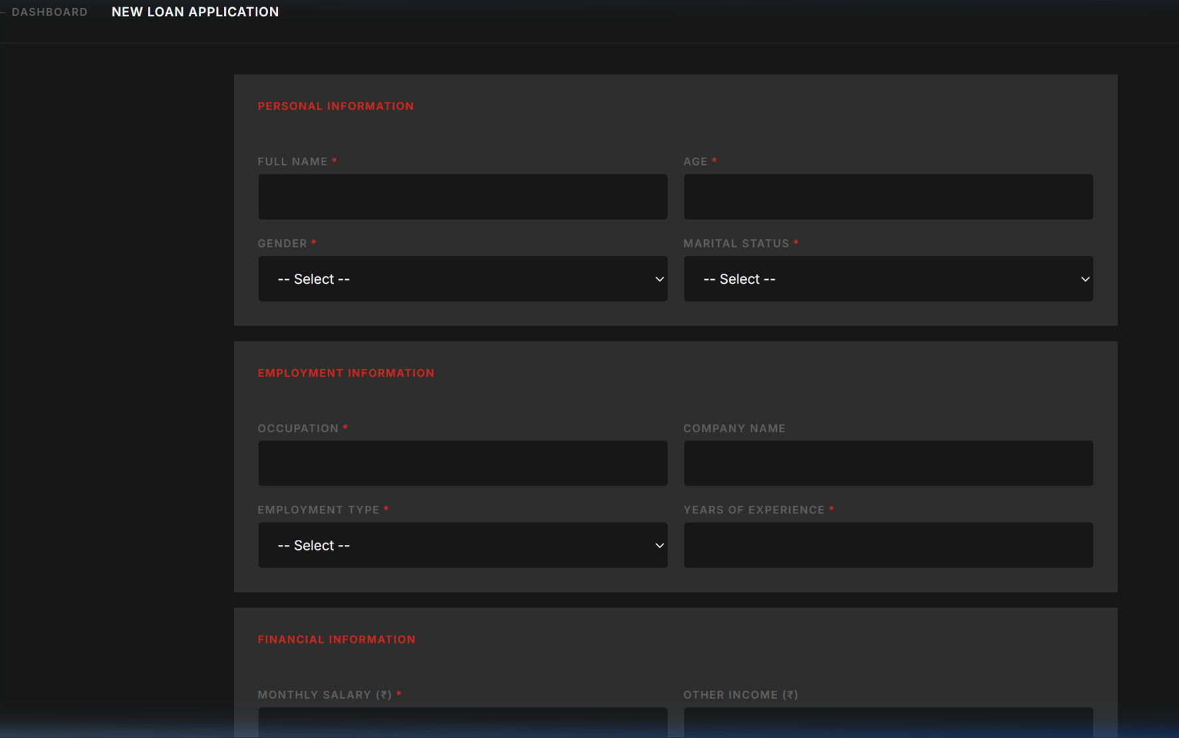

3.4 AI Prediction & Decision Screen
- Displays calculated FOIR, risk level badge, approval probability score, recommended amount headroom, and transparent reasoning list.
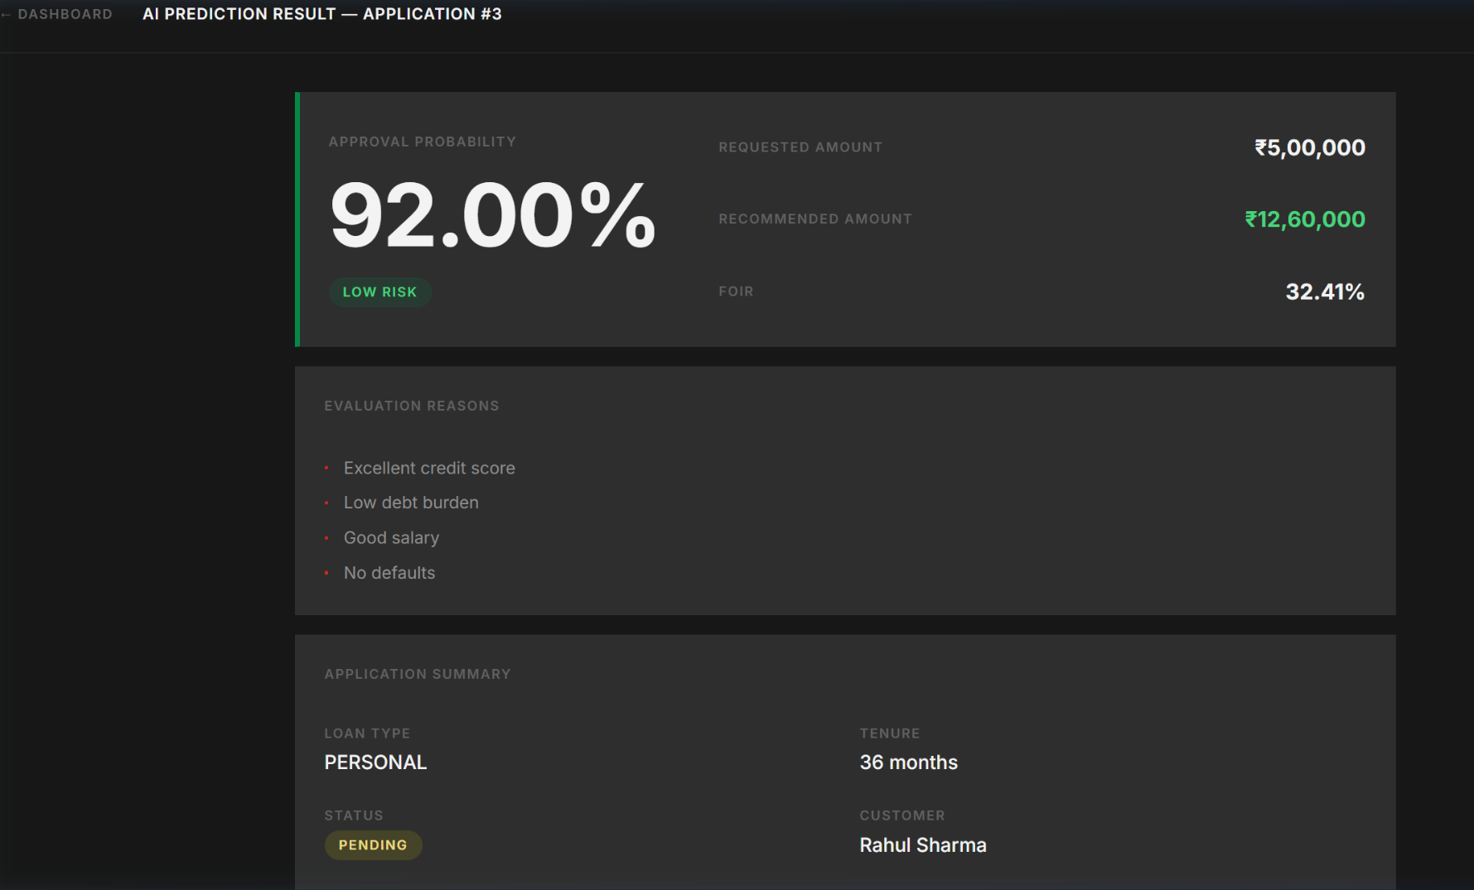
Live Test Results (Sample Case: Rahul Sharma)
- Applicant Profile: Salaried Senior Software Engineer, Monthly Salary ₹1,20,000, Existing EMI ₹25,000, Credit Score 780, 0 Missed Payments.
- Requested Loan: Personal Loan of ₹5,00,000 for 36 months.
- Engine Output:
  - FOIR: ​32.41%​ (Well below the 50% Salaried Cap)
  - Risk Tier: ​LOW RISK​
  - Approval Probability: ​92.00%​
  - Recommended Amount: ​₹12,60,000​
  - Reasons Generated: Excellent credit score, Low debt burden, Good salary, No defaults.

3.5 Approval Workflow & Real-Time Sync
- Single-click Approve or Reject decisioning for Pending applications.
- Automatic database sync and dashboard statistics update upon action execution.
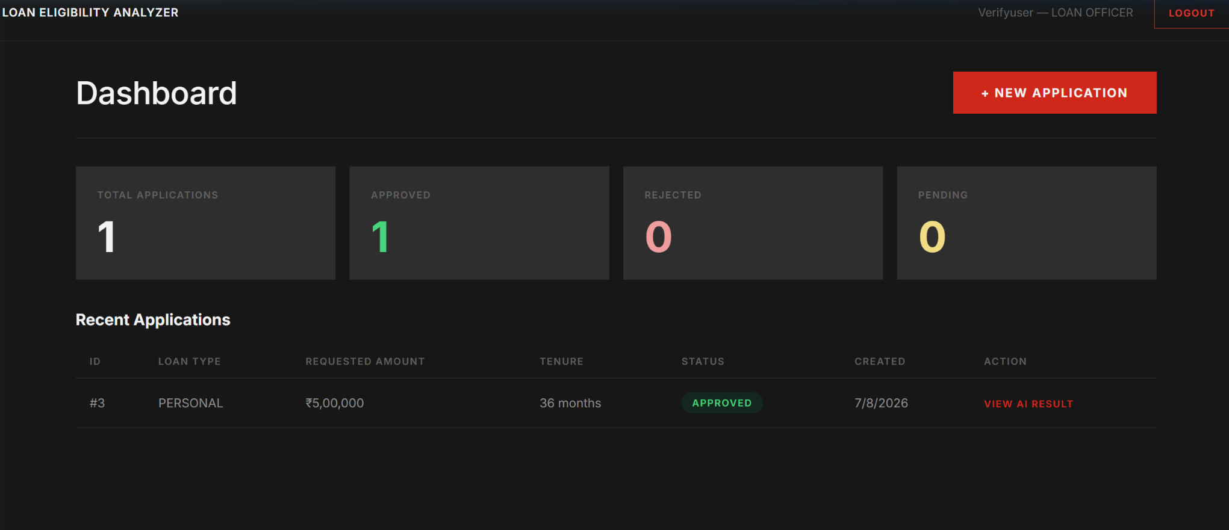

4. Codebase Audit & Reliability Enhancements
During the final audit of Phase 1, 15 potential bottlenecks and edge-case issues were identified and resolved across all system layers:
- Input Focus Stability: Refactored ​CustomerForm.jsx​ input wrappers to top-level definitions to eliminate component remounting and cursor focus loss.
- Database Connection Pool: Configured SQLAlchemy pool parameters (​pool_size=10​, ​max_overflow=20​, ​pool_pre_ping=True​) to prevent stale connection drops.
- Data Isolation: Updated FastAPI routers to enforce per-user ownership checks on loan records.
- Division-by-Zero Guards: Implemented strict non-zero checks in ​prediction_service.py​ for loan tenures and monthly income fields.
- Session Expiry Handling: Updated client-side router ​PrivateRoute​ with active JWT expiration parsing.
- Container Health Checking: Added PostgreSQL ​healthcheck​ definition in ​docker-compose.yml​ to prevent backend initialization race conditions.

5. Phase 1 Verification Summary
Component | Status | Verification Result
User Authentication & Auth Guards | ✅ Completed | JWT tokens properly generated and verified on all routes
Customer & Loan Application Intake | ✅ Completed | Full validation, accurate payload generation
Rule Engine (FOIR & Risk Scoring) | ✅ Completed | Risk matrix and calculation formulas verified against spec
Dashboard Analytics & Status Updates | ✅ Completed | Metrics match database state accurately
Container & Service Infrastructure | ✅ Completed | One-click​start.bat​ deployment verified
Conclusion: Phase 1 is fully completed , rigorously tested, and ready for baseline demonstration.
​

